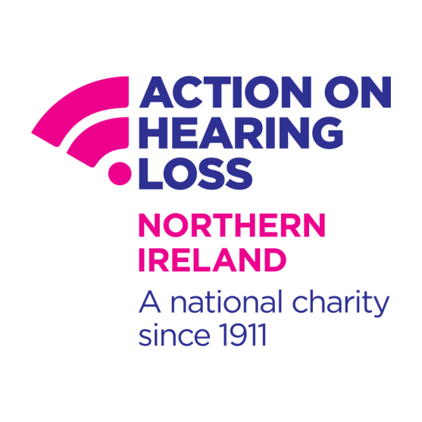**Do you wear NHS Hearing Aids?**

**Come to our FREE drop-in Hear to Help Clinic for:**

* New batteries and ear mould tubing
* Advice on how to use and clean your hearing aids
* Information on hearing loss and all the services that can help you

**When What time? Where?**

Fri 22nd Jan 2016 2pm – 4pm Donaghadee Health Centre

Fri 26th Feb 2016 10am – 12pm Portaferry Health Centre

Fri 25th Mar 2016 10am – 12pm Kircubbin Community Centre

Please note: we are a charity working with volunteers. Our clinics can get very busy - please bear with us while we try to help you

Interested in becoming a volunteer?

Please contact: **Joanne Wright** H2H Coordinator

**Mobile:** 07423 457 873 **Email :** [**Joanne.Wright@hearingloss.org.uk**](mailto:Joanne.Wright@hearingloss.org.uk)

Action on Hearing Loss is a registered charity in England and Wales (207720) and Scotland (SC038926).