**NEWSLETTER - DATES FOR YOUR DIARY 2014**

**DO NOT FORGET booking is required for EVENTS/ACTIVITIES**

**book by phoning 028 9127 1968 or e mail** [**agenda@agenorthdownards.co.uk**](mailto:agenda@agenorthdownards.co.uk)

call in to **24 Hamilton Road, Bangor 10am to 2pm Monday to Friday**

**Support & Signposting**

**Have you any concerns! Are there any issues we can help you with!**

**Do you need a listening ear! If we can’t help you we can signpost you to the right person who can support you.**

**Call in to 24 Hamilton Road, Bangor or telephone 028 9127 1968**

**Mon-Friday 10am to 2pm or email** [**agenda@agenorthdownards.co.uk**](mailto:agenda@agenorthdownards.co.uk)

**and we will do our best to help you.**

**CHRISTMAS TEA DANCE for the over 50’s**

**Wednesday 17th December 2014 Time – 11.30am – 2.00pm**

**Aurora Leisure Centre, 3 Valentine Road, Bangor, BT20 4UT**

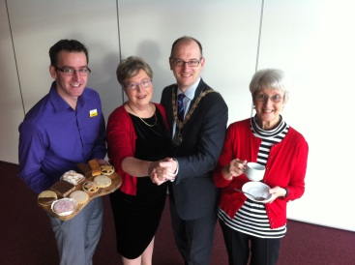**“Dance with Thomas”**

**Refreshments and light lunch will be served**

**Places are limited and MUST be booked through**

**AGE north down & ards Tel: 028 9127 1968**

**Monday – Friday 10.00am – 2.00pm**

**Email: agenda@agenorthdownards.co.uk**

**CHARITY BAG PACK – All proceeds will go to the Mayors Charities**

**(AGE north down & ards, The Royal British Legion, Christians Against Poverty, Flourish NI)**

**VOLUNTEERS Urgently required to help with Bag Packing**

**from 9am to 8pm on**

**Saturday 20th December in Tesco Bloomfields, Bangor**

**and**

**Tuesday 23rd December in Sainsburys Bangor**

**If you can help out for 1 hour please contact**

**AGE north down & ards Tel: 028 9127 1968**

**Monday – Friday 10.00am – 2.00pm**

**Email:** [**agenda@agenorthdownards.co.uk**](mailto:agenda@agenorthdownards.co.uk)

**PSNI Ecrime workshops**

AGE north down & ards have received funding to work in partnership with Police Service Northern Ireland to deliver information and training to the over 50’s on ECrime and reduce the fear of this type of crime. The following workshops have been set up and will be carried out on iPads (supplied in AGE north down & ards). If you would like to attend please register through AGE north down & ards Tel: 028 9127 1968 Monday – Friday 10.00am – 2.00pm or Email: agenda@agenorthdownards.co.uk

**Workshop 1 – Tuesday 13th January 2015 @ 10.00am in 24 Hamilton Road, Bangor**

**Silver Surfers, delivered by Neighbourhood Policing Team using**

**GetSafe Online**

**Workshop 2 – Tuesday 10th February 2015 @ 10.00am in 24 Hamilton Road, Bangor**

**on Bogus Caller & Fraud & Forgery delivered by Organised Crime Prevention**

There will also be a workshop in Spring on Domestic Violence delivered by Women’s Aid

**Good Morning Call Service**

**C:\Program Files (x86)\Microsoft Office\MEDIA\CAGCAT10\j0332268.wmfA FREE daily telephone service 365 days a year for those who live alone and at times feel anxious and vulnerable, and is available to all residents over 50 in North Down and Ards. Do you live alone? Do you know someone who is vulnerable? Are you anxious about being on your own? Are there days when no-one calls with you?**

**Would you like to hear a friendly voice in the mornings?**

**Then why not sign up for our FREE call service today? Peace of mind for you and your family……**

**Please contact AGE north down & ards Tel: 028 9127 1968 Monday – Friday 10.00am – 2.00pm or Email:** [**agenda@agenorthdownards.co.uk**](mailto:agenda@agenorthdownards.co.uk) **for a Referral Form.**

**Warm Homes Scheme**

**You may be eligible for free insulation if you own your home or rent privately and receive a qualifying benefit or tax credit**

**This is a fully funded scheme therefore there is no cost to homeowners,**

**tenants or landlords.**

**Contact the Warm Homes Team for information and advice on insulation**

**and central heating on 0800 988 0559 or visit** [**www.warm-homes.com**](http://www.warm-homes.com)

**AGE north down & ards (AGEnda) formerly age concern**

**Volunteers URGENTLY REQUIRED WITH BASIC COMPUTER SKILLS**

For more information and/or Volunteer Application form contact AGE north down & ards on 028 9127 1968 or call in to 24 Hamilton Road, Bangor Monday to Friday 10am to 2pm or email [**agenda@agenorthdownards.co.uk**](mailto:agenda@agenorthdownards.co.uk)

[](http://www.google.co.uk/url?sa=i&rct=j&q=&esrc=s&frm=1&source=images&cd=&cad=rja&uact=8&ved=0CAQQjRw&url=http://www.phrases.org.uk/meanings/my-cup-of-tea.html&ei=EmwIVNigFoOL7AbPvYCoBQ&bvm=bv.74649129,d.ZGU&psig=AFQjCNHlp4WQqo6IwLUkZtCfllmwfPiFlQ&ust=1409924498405589)**ARE YOU OVER 50? WE ARE HERE FOR YOU.**

**WHY NOT DROP IN FOR A CUP OF TEA & CHAT**

**READ THE DAILY PAPERS A WIDE RANGE OF BOOKS AVAILABLE**

**10AM – 2PM MONDAY TO FRIDAY**

**AGE north down & ards 24 HAMILTON ROAD, BANGOR**

**AGE north down & ards Floating Support Service is a FREE service that provides short term advice and help to make it easier for people to maintain their independence in the home and community, regardless of tenure (up to 2 years). The service is aimed at people 65 and over in the Ards Borough Council area who are deemed to be socially isolated. Please contact**

**AGE north down & ards for further information.**

**AGE north down & ards – Group/Activities**

|  |  |  |
| --- | --- | --- |
| **Group/Activity** | **Day** | **Time** |
| **Walking Group** | **Monday** | **10.15am** |
| **SHIP Shape “Have Fun & Dance”** | **Tuesday** | **10.30am** |
| **Hobbies & Craft class** | **Tuesday** | **2.00pm** |
| **REACH Mens Health Group** | **1st & 3rd Thursday** | **10.00am** |
| **Ladies Health Group** | **2nd & 4th Thursday** | **2.00pm** |
| **Wednesday Club** | **Wednesday** | **10.30am** |
| **Coffee Lounge/Drop-In** | **Monday - Friday** | **10am-2pm** |

**For information and details on all programmes above please contact:**

**AGE north down & ards Tel: 028 9127 1968 Monday – Friday 10.00am – 2.00pm Email:** [**agenda@agenorthdownards.co.uk**](mailto:agenda@agenorthdownards.co.uk)

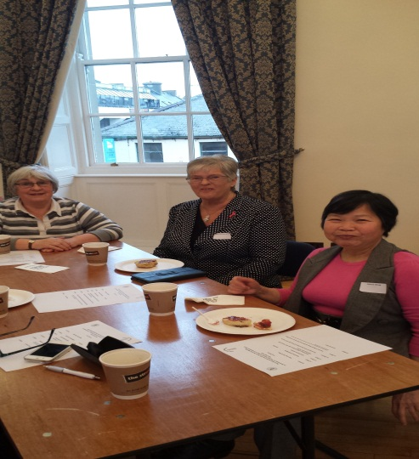

***North Down & Ards over 50’s Forum***

**Representatives from the newly formed**

**North Down & Ards over 50’s Forum**

**Management Committee in**

**Londonderry Room, Town Hall, Ards who are planning the launch of the new Forum in 2015.**

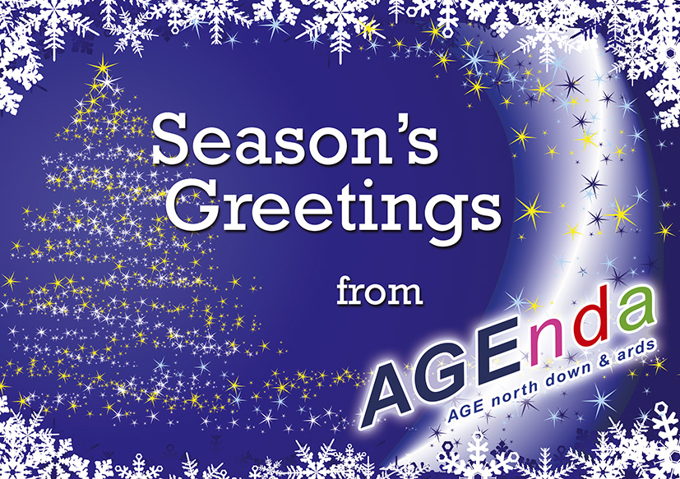**AGE north down & ards would like to take this opportunity to wish everyone a very Merry Christmas and a Happy New Year**

**ADVERTISEMENT**



**\\AGE01\RedirectedFolders\Janet\Desktop\LOGOS\North Down Borough Logo.jpg******